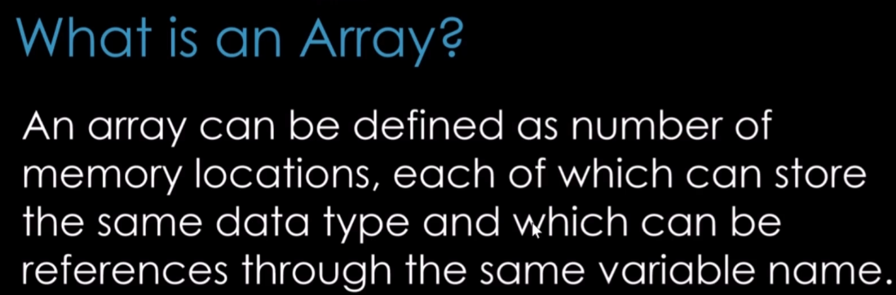

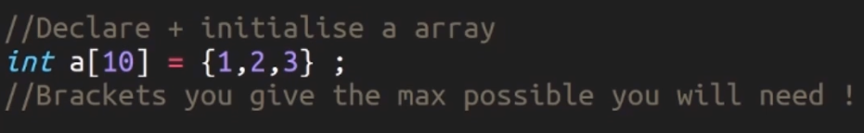

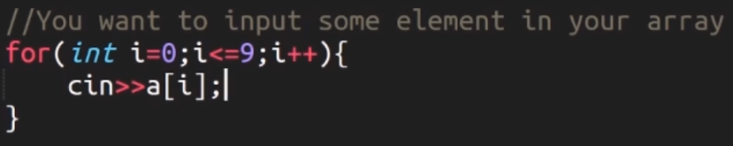

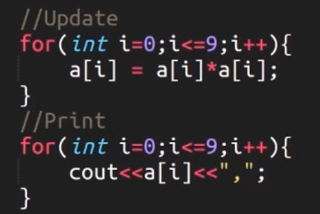

**Character Array:** In C++, it terminates with a null character **‘\0’.** When initializing a character array, we should always use null character at the end. The image below explains the reason. If we don’t explicitly set the null character, it will be set at the end of the array by default. When we print it will print the garbage values in between as well.

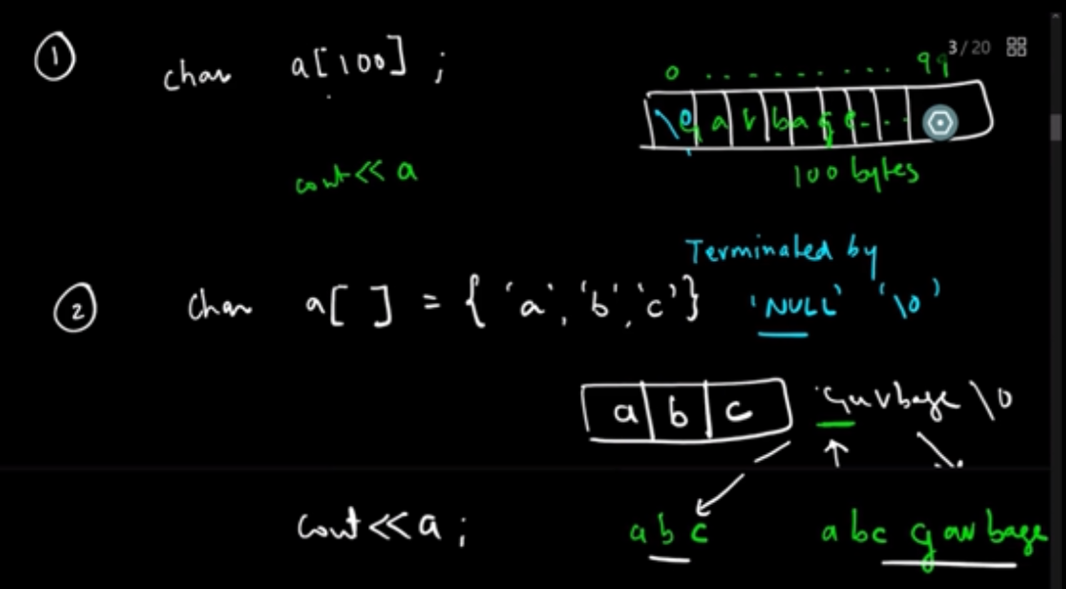

**Taking input of Character array:** There is basically two ways, cin and cin.getline. We can use cin when it’s a single word. But if it’s a line we need to get cin.getline. Reason being, cin gets terminated once it encounters a space.

**Strings from STL:**

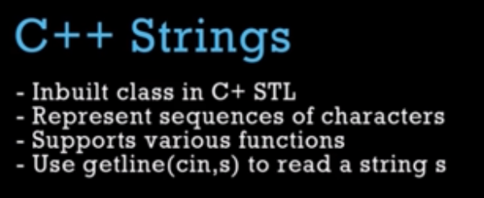

* Creating String via constructor 
* Creating String via assignment 
* Taking input for a string 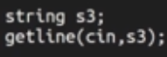
* 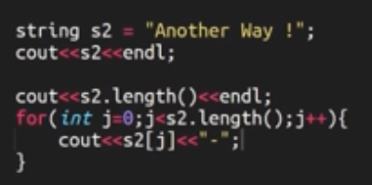Iterate over character of String



* Array of Strings

**Sorting String:** need to include the algorithm header file for this. We can use the sort function for this. First parameter is the start point of the array/vectorand second parameter is the length up to which we want to sort.



We can also define our own compare method, for example

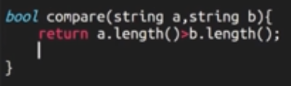



**Splitting Strings:** This is similar to Java split method.

